**E-ASSESSMENT USING IMAGE PROCESSING IN ∞EXAMS**

**ABSTRACT:**

This paper features a software system called ∞Exams (Infinity Exams) which supports (primarily in higher education) paper-based examination and makes it easier, more comfortable and speeds up the whole process while keeping every single positive attribute of it but also reducing the number of negative aspects. The approach significantly differs from the ones used in the previous 10+ years which were implemented in such a way that they could not reproduce and replace the traditional paper-based examination model. The heart of the article relies on the most important element of the software which is the image processing flow.

The way of conducting testing the knowledge of a person using Multiple Choice Questions (MCQ) has been increased gradually. In Educational industries (like schools and colleges) it is more common now days having tests using multiple choice questions. Even in conducting interviews it is used. Current day scenario is either using OMR technology to correct the test or manually. In real-time it is quite difficult to have OMR at all the time and manually it is highly taking the time to correct and it may give you the error. We address this issue, in our proposed system we using digital image processing technique to correct the answer using multi choice question in python. We are here using Open Source Computer Vision Library (Open CV) to process and correct the answer. Python is the best language to implement this concept with the available Open CV library. In this system we also implement in the django environment.

**INTRODUCTION:**

There is a growing need for storing paper-based information digitalized nowadays. This problem concerns education as well but it does not always get enough attention, however using our technology accordingly many aspects of the educational process could be made a lot simpler, easier, faster, more comfortable and (partially) automatable.

Most of the educational institutions are using traditional teaching and examination methods in most of their subjects still. Though the digitalization of teaching got a little bit of attention in the previous years and began its growth since then. Alongside it there are also computer-based examination methods but it is not the main functionality of the e-learning systems. So mostly the traditional examination models are used concerning those subjects who require such a way to be examined accordingly. From now on the paper-based examination method will be discussed, since it is the main concern of this paper. The keyword “e-assessment” refers to electronic assessment as software is used to mark the exam papers filled by the students after the exam is completed.

Multiple choices Question (MCQ) are a form of an objective [assessment](https://en.wikipedia.org/wiki/Educational_assessment) in which respondents are asked to select only correct answers out of the choices from a list.[[1]](https://en.wikipedia.org/wiki/Multiple_choice#cite_note-1) The multiple choice format is most frequently used in [educational](https://en.wikipedia.org/wiki/Education) testing, in [market research](https://en.wikipedia.org/wiki/Market_research), and in [elections](https://en.wikipedia.org/wiki/Elections), when a person chooses between multiple candidates, [parties](https://en.wikipedia.org/wiki/Political_party), or policies.

In this paper we are using image processing to accomplish the MCQ correction in very easy manner. It produces the great effort to deal to remove the barriers of multi choice assessment correction. In this we are using array format to correct the answer paper which is photo copier and uploaded by user. The main concept is to get the image and get the answer which is shadowed by user.

In Python Open CV library is available for image processing. In order to get the best effective output we use the django framework along with python. The Open CV is a library of programming functions mainly aimed at real-time computer vision. The Following topics are organized to explain the process of how to deal with this technique.

**EXISTING SYSTEM:**

The Multiple choice Question Pattern is most widely used to assess the details which are necessary. In current scenario Optical mark recognition OMRis most widely used to deal with multiple choice questions. But OMR sheets are corrected by the specialized machines to correct the answers. If you deal it in manually it will be very difficult to handle the data and accuracy also questioned. The manual work needed more effort, time and concentration to make it perfect. The existing system is dealing with many disadvantages.

**DISADVANTAGE**

The Main disadvantage of existing system is the necessity of the OMR machine to correct the answer. On the other hand the manual work is heavy and problems to deal with accuracy, time delay and people management.

**PROPOSED SYSTEM:**

The proposed system is taking the digital image of the answer sheet in the given pattern and uploads to the given system. In order to correct the answer digital image processing is used to get the answer sheet and proceed it to read the image. This method avoids the machine dependency and people dependency in high manner. This system brings out the effectiveness by using Django framework along with python in order to do image processing. The major impact is open CV library, which is available to access the image to get it as a matrix and make that very effective to deal with correcting answers in the image.

**ARCHITECTURE:**

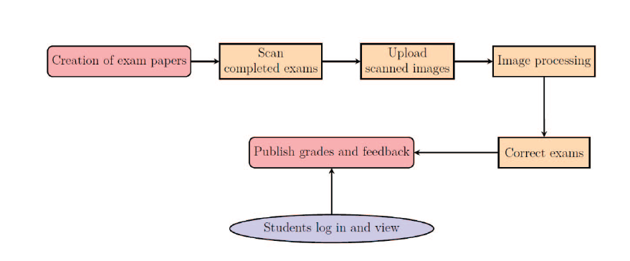

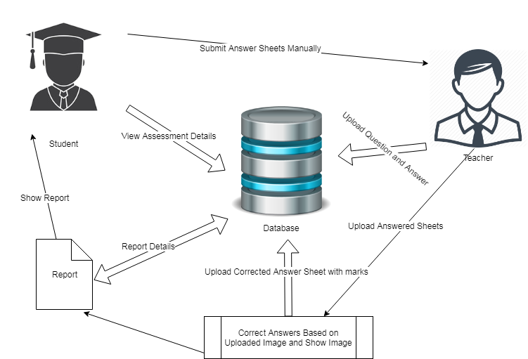

**ADVANTAGE:**

The proposed system is machine independent. The people management is very easy and very effective. It is also more cost effective because of not needed any special machines and resources are also needed very less. So it is very easy to access by dealing with the images.

**MODULES:**

This application has four modules which are listed in the following.

1. Student Management
2. Exam Assessment
3. Result Details
4. Graph Analysis

**MODULE DESCRIPTION:**

In this project there are four modules to achieve our expected result. These are the major functionalities of the project. The registration and login process are important to access the project for both users. There are two users’ admin (Teacher) and user (Student).

1. **Student Management**

The students are not directly registered. Faculty is uploading the bulk details of students with details of name, student id, class and so on. Students will receive manually student id from faculty manually. With the username and student id as password, student can authenticate to access the details. The details can be modified by students not by faculty at the same time student cannot modify their student id which given to them.

1. **Evaluation using Image Processing**

The Faculty will upload the students answer sheets as photos. Those photos can be evaluated with the help of Digital Image Processing technique. It can be achieved with the help of python’s opencv library. The matrix form is created with answer key to identify and give the result as per the photos.

1. **Result Analysis**

The results from the above module are handled by some math functions to put those values into calculations. Get the total marks accomplished by students and average of the student can be calculated by the auto functionalities and display to users.

1. **Graph Analysis**

The graph analysis is done by the values taken from the result analysis part and it can be analyzed by the graphical representations. Such as pie chart, pyramid chart and funnel chart here in this project.

**CONCLUSION:**

The featured so-called ∞Exams software system is in alpha version which means that the previously envisioned functionalities have been partially implemented and can be used. The software has a desktop application in which the users can generate exam sheets, browse and edit the database, upload images and correct the exams. The already implemented framework gives a nice look at how the whole system will be assembled. At this very moment, the software can only be used in offline mode.

The functionalities of the system have already been tested with more than a 100 exam sheets filled out by students solely for this purpose. The image processing part of the system has given satisfactory results as it seemed fast enough to process even a massive number of images at once without a single error.

It is beyond doubt that the further development potential of the ∞Exams software system is great and by seizing this opportunity, when it will be completed and released, it could play a considerable role in the future of the revolution of the digitalization of education.

The MCQ Test correction is major way of assessment in the current scenario. MCQ Test format have different way of correction and conducting the tests which is very difficult. The proposed system addresses the issue and solving this problem with the help of Image Processing and Django Framework. Both of these techniques were very handy to solve the problems in MCQ Test Correction. It has its own limitations which are solved in future but as for current scenario it is better solution among the existing ideas. In future can able to have many services to be included in this application.